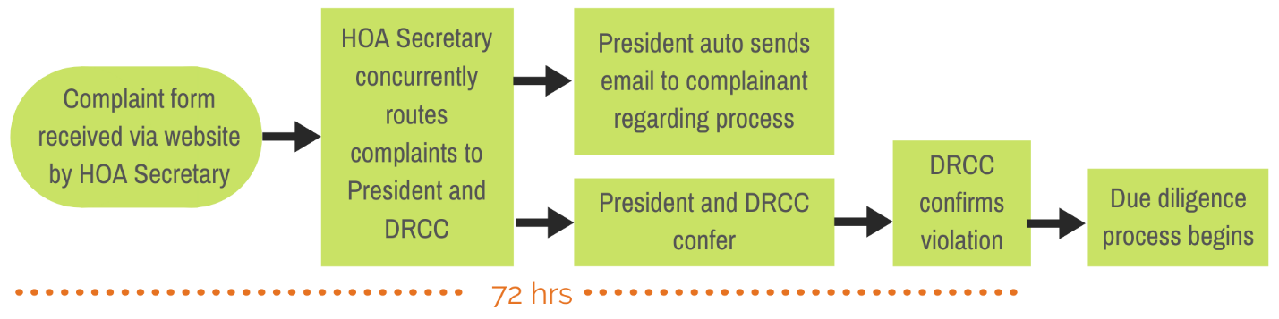

HOA Deed Restriction Compliance & Enforcement Protocol

Dear Resident,
Please note the above flow chart which explains your role in the onset of this process. Once the violation is confirmed, the Enforcement process is designed to proceed from beginning to final action, for approximately 30 days.
1. You are aware of the Deed Enforcement tab on the FLCCE.com website. It is here that a resident who wishes to provide notice of an address requiring deed restriction enforcement, fills out the appropriate request via the Form provided.
2. The Resident providing notice, will receive a reply from the HOA within 72 hours, acknowledging receipt of the form and the timeframe during which most non-compliance issues are addressed.
3. From that point the process will include notice(s) to the Owner of the Residence of Offense. It is during this period of time that the Deed Restriction& Enforcement Compliance, (DREC) Team will conduct its due diligence. If the issue cannot be resolved, the DREC Team may look to the HOA Board who will then determine if legal pursuit, or some other step is necessary. If legal pursuit is deemed necessary, then time will lapse beyond the thirty-day HOA process.
4. Though you may not see immediate action, that does not mean the DREC Team is not addressing the issue. Please allow the process to occur with patience. If, you wish to follow up after 30 days to learn the status of the offense, you may do so at the same email address in which you filled out the form.
5. Thank you for caring enough to inform the HOA board of any Deed Restriction non-compliance issues.

